1 close all; clear all; 2
3 %% A simple example using MATLAB 4 load score_data % input N score 5
6 N=input(' number of student: '); 7 score=zeros(2,N);
8
9 % input the name and score of the student evaluate the average score 10 for i=1:N
- str1= input('student name:','s');
- eval(['name',int2str(i),'=str1;']); 13 % if (i==1)
- % name=str1;
- % else
- % name=char(name,str1); % Create a character array. 17 % end
18 score(1,i)=input('math score: '); 19 score(2,i)=input('english score: ');
20 avg(i)=(score(1,i)+score(2,i))/2; % avg(i) = sum(score(:,i))/2; 21 end
22
23 % output value 24 for i=1:N
- eval(['str1=name',int2str(i),';']);
- fprintf('the average score of %s is %3.2f \n',str1,avg(i)); 27 end
28 save score_data N score

Table 2.1 : 變數名稱限制與規定

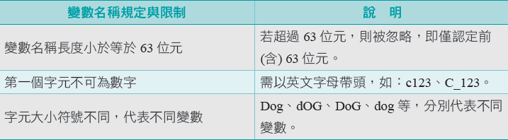

Table 2.2 : Constant symbol (Cannot be used as variable name)

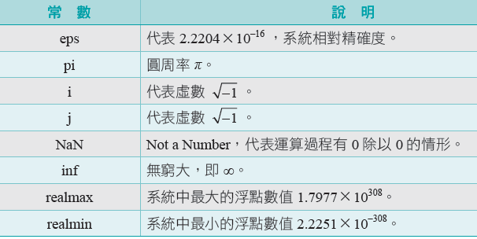

30 %% prog 2.3-1 Variable stored as array 31 % Array (scalar, vector, matrix0 in matlab 32 % vectors, and matrices...
33
Table 2.3 (I) : Intialize row vector

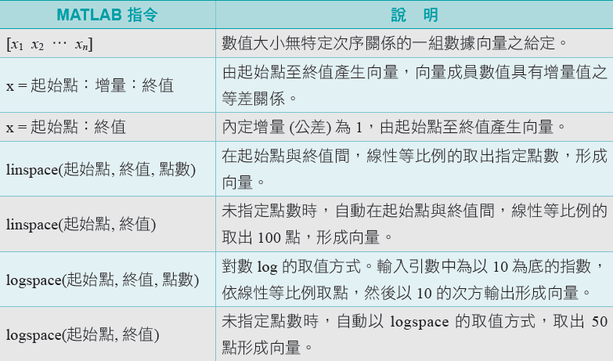

- N = 5 % a scalar
- v = [1 0 0] % a row vector
- v = [1;2;3] % a column vector
- v = v' % transpose a vector (row to column or column to row) 39 v = [1:.5:3] % a vector in a specified range:
40 v = pi*[-4:4]/4 % [start:stepsize:end] 41 v = [] % empty vector
42
43
- m = [1 2 3; 4 5 6] % a matrix: 1ST parameter is ROWS, 2ND parameter is COLS
- m = zeros(2,3) % a matrix of zeros
- v = ones(1,3) % a matrix of ones 48 m = eye(3) % identity matrix
- v = rand(3,1) % rand matrix (see also randn)
- save matrix_data m % save the variable m to a file named matrix_data.mat 51
52 clear all % clear all variables currently used by MATLAB 53
54 load matrix_data % read data from the saved file 55 m % display it - it is still there! 56
57 v = [1 2 3]; % access a vector element 58 length(v) % length of a vector
59 v(2:3) % vector(number) 60
61
62 % 2.3.5 subscripts
63 a=[ 1 2 3 4 5 6 7 8];
64 a(2:6)
65 a(2:2:6)
66
67 m = [1 2 3; 4 5 6;7 8 9]
68 | m(1,3) |  | % access a matrix element
69 |  | % | matrix(rownumber, columnnumber)
70 | m(2,:) |  | % access a matrix row (2nd row)
71 | m(:,1) |  | % access a matrix column (1st row)
72
73
74 | size(m) |  | % size of a matrix
75 | size(m,1) |  | % number rows
76 | size(m,2) |  | % number of columns
77
78
79 % to chane the value by finding the subscript 80
81 [i j]=find(m>=3);
82 disp([i j]);
83
84 pp=find(m>=3);
85 m(pp)=0
86
87
88 m1 = zeros(size(m)) % create a new matrix with size of m 89
- who % list of variables

- whos % list/size/type of variables 92
- %% chap2.5-1 Array operations
- % (A) Pointwise (element by element) Operations: 95
96 % addition of vectors/matrices and multiplication by a scalar 97 % are done "element by element"
98 a = [1 2 3 4]; % vector
- 2 * a % scalar multiplication
- a / 4 % scalar multiplication 101 b = [5 6 7 8]; % vector
- a + b % pointwise vector addition
- a - b % pointwise vector addition
- a .^ 2 % pointise vector squaring (note .)
- a .* b % pointwise vector multiply (note .)
- a ./ b % pointwise vector multiply (note .) 107
- log( [1 2 3 4] ) % pointwise arithmetic operation
- round( [1.5 2; 2.2 3.1] ) % pointwise arithmetic operation
- 110
- 111
112 | %%%%%%%%%%%%%%%%%%%%%%%%%%%%%%%%%%%%%%%%%%%%%
113 | % (B) Vector Operations (no for loops needed)
114 | % Built-in matlab functions operate on vectors, if a matrix is given,
115 | % then the function operates on each column of the matrix
116
117 a = [1 4 6 3] % vector
- sum(a) % sum of vector elements
- mean(a) % mean of vector elements
- var(a) % variance (sigma^{2})
- std(a) % standard deviation (sigma)
- max(a) % maximum 123
124
125 a = [1 2 3; 4 5 6] % matrix
- mean(a) % mean of each column
- max(a) % max of each column 128 max(max(a)) % to obtain max of matrix
129 max(a(:)) % another way to obtain max of matrix 130
131
132 xx = linspace(0, pi/2, 10)
133
- yy = logspace(0, 2, 10)
- % ddy=diff(yy);

136 | % yy1=yy(1:end-1+ddy./2);
137 | % figure(1);plot(yy1,ddy)
138
139 | %%%%%%%%%%%%%%%%%%%%%%%%
140 | % (C) Matrix Operations:
141
142 | [1 2 3] * [4 5 6]' % row vector 1x3 times column vector 3x1
143 | % results in single number, also
144 | % known as dot product or inner product
145
146 | [1 2 3]' * [4 5 6] % column vector 3x1 times row vector 1x3
147 | % results in 3x3 matrix, also
148 | % known as outer product
149
150 | a = rand(3,2) % 3x2 matrix
151 | b = rand(2,4) % 2x4 matrix
152 | c = a * b % 3x4 matrix
153
154 | a = [1 2; 3 4; 5 6] % 3 x 2 matrix
155 | b = [5 6 7]; % 3 x 1 vector
156 | b * a % matrix multiply
157 | a' * b' % matrix multiply
158
159 | %%
160 | %(D) Saving your work
161
162 | save mysession % creates session.mat with all variables
163 | save mysession a b % save only variables a and b
164
165
166 | clear a b % clear variables a and b
167 | clear all % clear all variables
168
169 | load mysession % load session
170 | a
171 | b
172
173
174 | %% Prog 2.6 format , disp statement
175
176 | format long % (1) short e ; (2) bank (3) compact
177 | x=[ 1e3 1 1e-4]
178
179 | % 2.7-1 p. 58 square roots with newton's method
180 | a = 2;

181 | % a=input('input a number for the computation:');
182 | x = a/2;
183 | % display a variable
184 | disp(['The approach to sqrt(a) for a =', num2str(a)]) % | an str variable
185 | for i = 1:6
186 | x = (x + a / x) / 2;
187 | disp( x )
188 | end
189 | disp( 'Matlab''s value: ' )
190 | disp( sqrt(a) )
191
192 | aa=[1:4] % row vector
193 | bb=[5:8]
194 | disp([aa' bb']) % a matrix variable of 4*2 matrix
195
196 | aa=[-pi:0.25*pi:pi]
197 | disp([ aa' sin(aa)'] ) % math. expression
198
199 | format
200 | Table 2.6: (Common Input-Output functions)  A1 = [9.9, 9900];  A2 = [8.8, 7.7 ; ...  8800, 7700];  formatSpec = 'X is %4.2f meters or %8.3f mm\n';  fprintf(formatSpec,A1,A2)  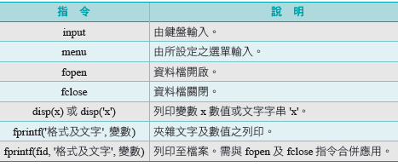  fprintf format  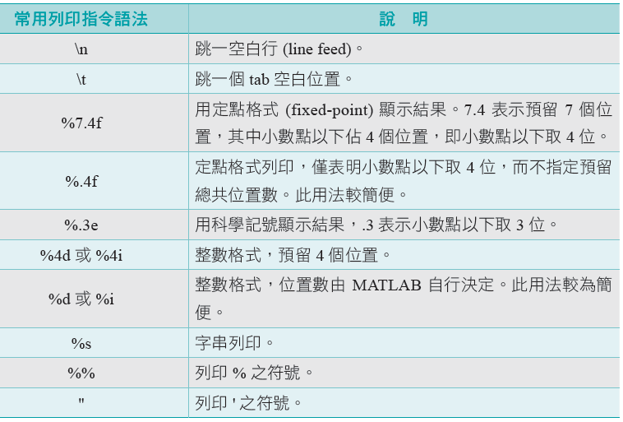
201 | %%%%%%%%%%%%%%%%%%%%%%%%%%%%%%%%%%%%%%%%%%%%%%%%%%%%%%%%%%%%%%%%%%%%%%%
202 | % 2.7 Prog 2.7-1 Repeating with for statements
203
204 | % Example: given a vector v, create a new vector with values equal to
205 | % v if they are greater than 0, and equal to 0 if they less |  | than | or
206 | % equal to 0.
207
208
209 | v = [3 5 -2 5 -1 0]; % 1: FOR LOOPS
210 | % initialize; generate zero matrix with same dimension
211 | u = zeros( size(v) );
212 | for i = 1:length(v)
213 | disp([i v(i)]); % i=1 then [i v(i)]=[ 1 3 ]
214 | if( v(i) > 0 )
215 | u(i) = v(i);
216 | end

217 | end
218 | u
219
220 | v | = | [3 5 -2 5 -1 0] |  | % | 2: NO FOR LOOPS
221 | u2 | = | zeros( size(v) | ); | % | initialize
222 | ind | = | find( v>0 ) |  | % | index into >0 elements
223 | u2(ind) = v( ind )
224
225 | %% Exercise For loop |  |  | p.78 translate between Celsius and Fahrenheit

226
227 | % input
228 | % the initial value of the temperture in degree C : 20
229 | % the final value of the temperture in degree C : 30
230 | % the step of the temperture in degree C f: 2
231
232 | % output using fprintf
233 | % Celsius 20.00 Fahrenheit 68.00
234 | % Celsius 22.00 Fahrenheit 71.60
235 | % Celsius 24.00 Fahrenheit 75.20
236 | % Celsius 26.00 Fahrenheit 78.80
237 | % Celsius 28.00 Fahrenheit 82.40
238 | % Celsius 30.00 Fahrenheit 86.00
239
240
241 | %%=========================================================================
242 | Avoid "for" loops by vectorizing
243 | %%=========================================================================
244
245 | t0 = clock;
246 | s = 0;
247 | for n = 1:100000
248 | s = s + n;
249 | end
250 | etime(clock, t0)
251
252 | t0 = clock;
253 | n = 1:100000;
254 | s = sum( n );
255 | etime(clock, t0)
256
257 | %%=========================================================================
258 | %%=========================================================================
259 | % pp. 62 : sum(1/n^2) for n=1:100000
260 | tic
261 | s = | 0;
262 | for | n = 1:100000
263 | s = | s + 1/n^2;
264 | end
265 | toc
266
267 | % n | is a vector
268 | tic
269 | n = | 1:100000;
270 | s = | sum( 1./n.^2 );

271 toc
272
273
274 %%=========================================================================
275 %%=========================================================================
276
277 % p.63
278 sign = -1;
279 s = 0;
280 for n = 1:9999
- sign = -sign;
- s = s + sign / n;
- end
- display(s);
- 285
- % n is a vector 287 n = 1:2:9999;
288 s = sum( 1./n - 1./(n+1) )
289
290 %% Exercise
291
292 % input the number of the student 293 clear all;close all;
294 N=input(' number of student: '); 295 score=zeros(2,N);
296 % input the name and score of the student evaluate the average score 297 MAXN=10;
- name=zeros(MAXN,10);
- for i=1:N
- name(i,:)= input('student name:','s'); 301 score(1,i)=input('math score: '); 302 score(2,i)=input('english score: ');
303 avg(i)=(score(1,i)+score(2,i))/2; % avg(i) = sum(score(:,i))/2; 304 end
305 % output value 306 for i=1:N
307 fprintf('the average score of %s is %3.2f \n',name(i,:),avg(i)); 308 end
309
310
311 %%=========================================================================
312 % 2.8.2 p. 66 if-lese statement
313 %%=========================================================================
314 % Relational operations p.65 table 2,4 315 x= (3>2)

316 x= (2>3)
317 x= (3==3)
318
319 bal = 10000 * rand;
320 if bal < 5000 % relational 321 rate = 0.09;
322 else
323 rate = 0.12;
- end
- newbal = bal + rate * bal;
- disp( 'New balance after interest compounded is:' ) 327 format bank
328 disp( newbal ) 329
330
331 %%=========================================================================
332 % 2.8.4 p. 67 elseif statement
333 %%=========================================================================
334
335
336 bal = 15000 * rand;
337 if bal < 5000
338 rate = 0.09;
339 elseif bal < 10000
340 rate = 0.12;
341 else
342 rate = 0.15;
- end
- newbal = bal + rate * bal; 345 format bank
346 disp( 'New balance is:' ) 347 disp( newbal )
348
349
350
351
352 %%=========================================================================
353 % multiple logical condition
354 %%=========================================================================
355 bal=7000;
356 rate=0;
357 if ((5000 < bal) & (bal< 10000)) % if 5000 < bal < 10000 (wrong)
358 rate = 0.12;
- end
- newbal = bal + rate * bal;

- format bank
- disp( 'New balance is:' ) 363 disp( newbal )
364
365
366
367 %%=========================================================================
368 % 2.8.9 p. 71 switsh elseif statement
369 %%=========================================================================
370
- d = floor(3*rand) + 1
- switch d
- case 1
- disp('That''s a 1!' );
- case 2
- disp( 'That''s a 2!');
- otherwise
- disp( 'Must be 3!');
- end
- 380
- 381
- 382
- d = floor(10*rand);
- switch d
385 case {2, 4, 6, 8}
386 disp( 'Even' );
387 case {1, 3, 5, 7, 9}
388 disp( 'Odd' ); 389 otherwise
390 disp( 'Zero' ); 391 end
392
- %% Exercise
- % (1) score case.
395 % (2) Hw. 1
396 % (3) To write the code for the root of quadratic equation in p. 94
397 %%=========================================================================
398 % complex number p. 72
399 %%=========================================================================
400
401 i=sqrt(-1);
402 circle = exp( 2*i*[1:360]*pi/360 ); 403 figure, plot(circle)
404 % axis([-1 1 -2 2])
405 axis('equal')

406 axis([-2 2 -2 2])
407
408 a=3;
409 b=5;
410 a=[a b];
411 b=a(1);
412 a(1)=[]
413 %%=========================================================================
414 %%=========================================================================
415
416 a = [1+i 2+2i; 3+3i 4+4i]
417 a'
418 a.'
419
420
421 %%=========================================================================
422 %%=========================================================================
423 tic
424 k=1:40000;
425 s=sum(1./k.^2);
426 disp(sqrt(6*s))
427 toc
428
429
430 clc;clear;close all
431
432 money=50;%%本金
433 newBalance = zeros(1,12); 434
435 for k=1:12 %% 月份
436 money = money *1.01;%%本金加利息
437 newBalance(k)=money;%%每月存款結算
438 money=money+50;%%每月定存439 end
440
441 display(['Month' ' New Balance']);
442 display(num2str([ (1:12)' newBalance' ]));
443
444
445 %% Exercise answer 446 close all;clear all; 447
448 aa = floor(100*rand(20,1)) + 1
449 for i=1:length(aa)
450 bb(i)='n';

451 if (aa (i) >= 60)
452 bb(i)='p';
453 end
454 disp([ ' ' num2str(aa(i)) ' ' bb(i) ]); 455 end
456
457
458

